|  |
| --- |
| **5.6 Constructing a Logic Model** |



*To create a logic model that will guide the implementation, monitoring, and eventual evaluation of the initiative.*

The data team will determine the logical connection of the intervention to the desired outcome and express the connections as If…Then propositions.

About 20 minutes to introduce and additional time to complete.



A logic model will help your team determine and illustrate the logical connection of the intervention that you design to the desired end states (outcomes). *If … then….* logic statements form the bridge between the strategies and objectives of your intervention and the desired outcomes. This relationship is illustrated on page 42. By keeping these logical connections between the intervention and the desired outcomes, the team will be able to move forward efficiently and effectively.

**Directions:**

**Part 1: Reviewing an Example**

1. Review the *Logic Model Example* provided on page 42.

**Part 2: Developing a Logic Model**

1. Record the learner-centered problem statement and the problem of practice statement that the team previously developed in the template.

Using the skills that you developed in tools **5.1 Describing the Desired End State** and **5.2 Writing Measurable Statements**, generate improvement targets for the learner-centered problem and the problem of practice. Record them on the template.

Record the high-impact strategies that the team selected using tool **5.4 Rating Strategies’ Potential for Success** in the template.

For each strategy, develop a measurable objective that will guide the implementation of that strategy. Each objective should be narrow in focus and guide only one aspect of the implementation or outcome of the strategy. It is common to have several objectives associated with each strategy. Expand the template as necessary.

**Logic Model Example**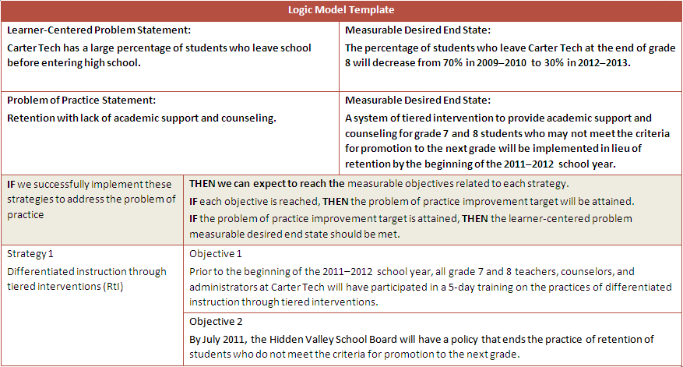

| **Logic Model** | | |
| --- | --- | --- |
| **Learner-Centered Problem Statement:** | | **Measurable Desired End State:** |
| **Problem of Practice Statement :** | | **Measurable Desired End State:** |
| **If** we successfully implement these strategies to address the problem of practice | **Then we can expect to reach the** measurable objectives related to each strategy.  **If** each objective is reached, **Then** the problem of practice improvement target will be attained.  **If** the problem of practice improvement target is attained, **Then** the learner-centered problem measurable desired end state should be met. | |
| Strategy 1 | Objective 1 | |
| Objective 2 | |
| Strategy 2 | Objective 1 | |
| Objective 2 | |
| Strategy … | Objective 1 | |
| Objective 2 | |

**Logic Model Template**